Merchant Maintenance Form

User Login

Purpose
The Login screen allows authorized users to access the application using their registered credentials.

Procedure
- Open the application.
- Enter your registered email address in the Email Address field.
- Enter your password in the Password field.
- Click the Eye icon to view or hide the password if required.
- If you have forgotten your password, click the Forgot Password? link to reset it.
- Click the Log In button.
Result:
After successful authentication, the user will be redirected to the application's Home/Dashboard screen.
.

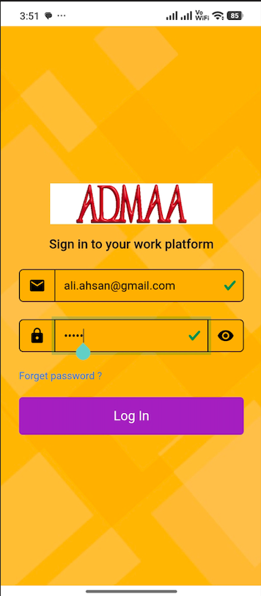

Open the Task Section

Purpose
The Task section provides access to available forms within the application.

Procedure
- From the bottom navigation menu, select the Task tab.
- On the Task screen, click the Plus (+) button located at the bottom-right corner.
Result:
The form search screen will be displayed.

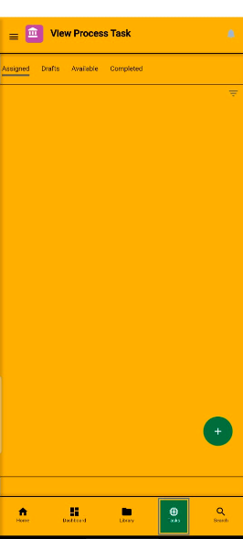

Search and Open the Merchant Maintenance Form

Purpose
The search screen enables users to locate and open the required form.

Procedure
- Enter Merchant Maintenance in the search box.
- The Merchant Maintenance form will appear in the search results.
- Click the Merchant Maintenance form card to open it.
Result:
The Merchant Maintenance form will open, allowing the user to begin entering the required information.

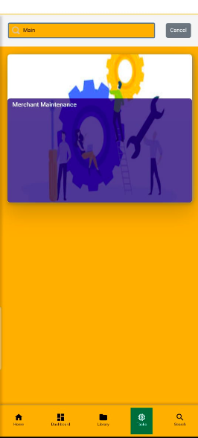

Merchant Maintenance – Update Request

Purpose
The Merchant Maintenance form allows users to submit maintenance requests for an existing merchant. Users can either report an issue related to the merchant or request updates to the merchant's account and product information.

Procedure
- Select the required merchant from the Select Merchant dropdown list.
- Choose the appropriate maintenance request type:
  - Issues

If Issues is selected:
- Click the Enter Issues button.
- Enter a clear description of the issue in the provided text box.
- Review the entered information.
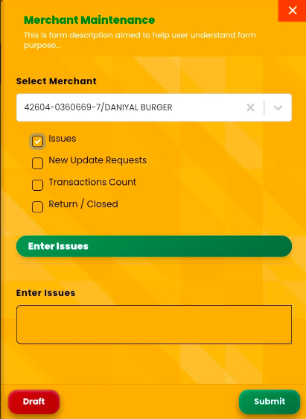

New Update Request
- Select the Type.
- Select the Bank Partner.
- Choose either a New Account or Existing Account.
- If applicable, enable the Product Offer option.
- Select the Product Offer.
- Select the Product.
- Enter the Product Category, if applicable.
- Under the Information section, select the QR Type.
- Enter the QR Quantity.
- Click the Add (+) button to add the QR details.
- If required, use the Delete (-) button to remove an existing record.
- Review all the entered information before submission.

Available Actions
- Add (+) – Adds the entered QR details to the list.
- Delete (-) – Removes the selected QR record from the list.
- Draft – Saves the maintenance request as a draft for completion at a later time.
- Submit – Validates the entered information and submits the maintenance request for further processing.

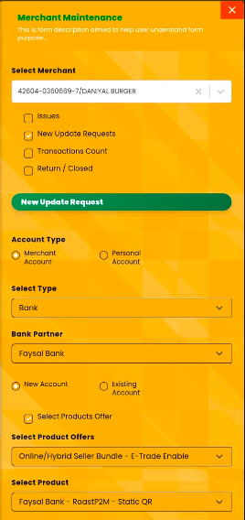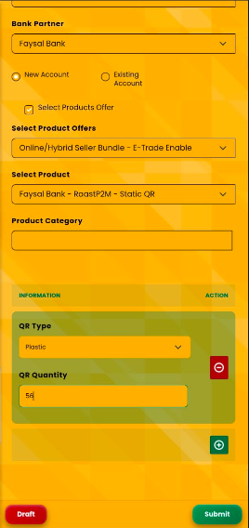

Transaction Count

Purpose
The Transaction Count option is used to submit a request for reviewing or updating the transaction activity of a selected merchant. This enables users to verify the merchant's transaction volume for a specified period.

Procedure
- Select the required merchant from the Select Merchant dropdown.
- Select the Transaction Count option.
- Click Add Transaction Count to create a new transaction count request.
- Select the Transaction Duration.
- Select the From Date.
- Select the To Date.
- Enter the Transaction Amount.
- If applicable, select the Product Offer.
- Review the entered information before submission.

Available Actions
- Draft – Saves the transaction count request as a draft for completion at a later time.
- Submit – Validates the entered information and submits the request for further processing.

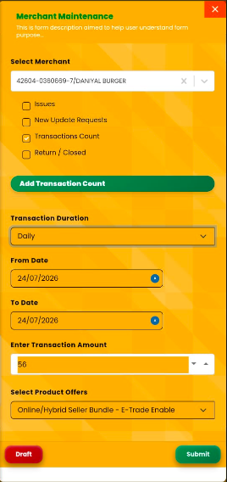

Return / Closed

Purpose
The Return / Closed option is used when a merchant wants to return the QR code or permanently close their merchant account.

Procedure
Select the required merchant from the Select Merchant dropdown.
Select the Return / Closed checkbox.
Choose the appropriate status from the Select Status dropdown:
- Return – Select this option when the merchant wants to return the QR code.
- Closed – Select this option when the merchant wants to permanently close the merchant account.
Enter the reason for the request in the Enter Reason field.
Upload the required supporting image or document in the Closed Shop Picture section as evidence.
If applicable, select the appropriate option from the Select Product Offers dropdown.
Click Submit to submit the request.
Alternatively, click Draft to save the request for later.

Result
The return or account closure request will be submitted successfully and forwarded for verification and further processing.

